Pod Breakdown - What Is a Pod & Infrastructure

A pod is a business inside of the business. It is a consolidated team of people who work in conjunction with one another in order to support and manage their client base

One pod on average tends to handle 40-50 clients

That pod should see themselves as running their own book of clients, responsible for getting them results and ultimately keeping them happy

What team members are inside of a pod?

Pod specific team members:
- Client success manager (pod lead)
- Media Buyer
- Ops Assistant (you)
- 4x client sales representatives
Shared team members across pods:
- Project Manager
- Call center manager
- Fulfilment manager
- Appointment confirmation specialist

What does the pod structure look like?

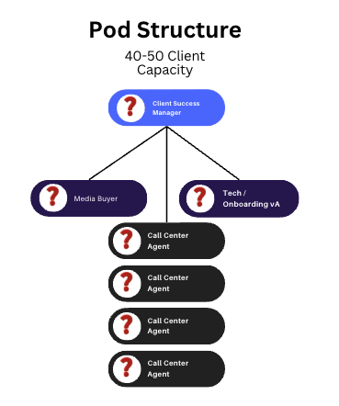

- Clients per pod: 40-50
- Revenue per pod: $90,200 - $112,750 (Avg client pays $2255 per month)
  - 12% Churn Avg
  - 3% Grace Period (meaning they are given an extension and do not pay that month)
    - Starting Clients: 40
    - Churn (12%): 40 * 0.12 = 4.8 clients lost
    - Grace Period (3%): 40 * 0.03 = 1.2 clients on grace period
    - Paying Clients: 40 - (4.8 + 1.2) = 34 paying clients
    - Average Payment Per Client: $2,255
- Minimum Revenue To Be Made Per Pod: $76,670
- Cost Per Pod:

Labor
  - Pod-Specific Team Members
    - 1 AM / $5000
    - 1 Media Buyer / $1000
    - 1 Tech Specialist / $1200
    - 4 Client Sales Reps / $8000 ($2000 each on average)
  - Shared Team Members
    - Call Center Manager / $4000
    - Operations Manager / $8500
    - Client Fulfilment Manager / $4000
    - Tech Expert & Manager / $2000
Overhead
  - Fixed Pod Costs: $15,200
  - Variable Pod Cost (Split between 3 pods): $6,166

- Total Flat Expenses: $21,366
- Profit Target: $55,304
- Profit Margin Target: 72.1%

